|  |
| --- |
| ***Portfolio*: The Wealth of nations.**      18/10/2024    Monica Gonzalez Gonzalez |



Your rights 14

Your rights 14

Como

Table of Contents of Portfolio: The Wealth of nations.

Main body ....................................................................................................................

A reflective..................................................................................................................

**Scenario** ..............................................................................................................................

**First Task** .............................................................................................................

**Policies and Procedures ...................................................................................................**

**Second task**.............................................................................................................

**Excel** ......................................................................................................................................

**The data** .................................................................................................................................

**Third Task** ...........................................................................................................................

**Tableau** .........

Main body:

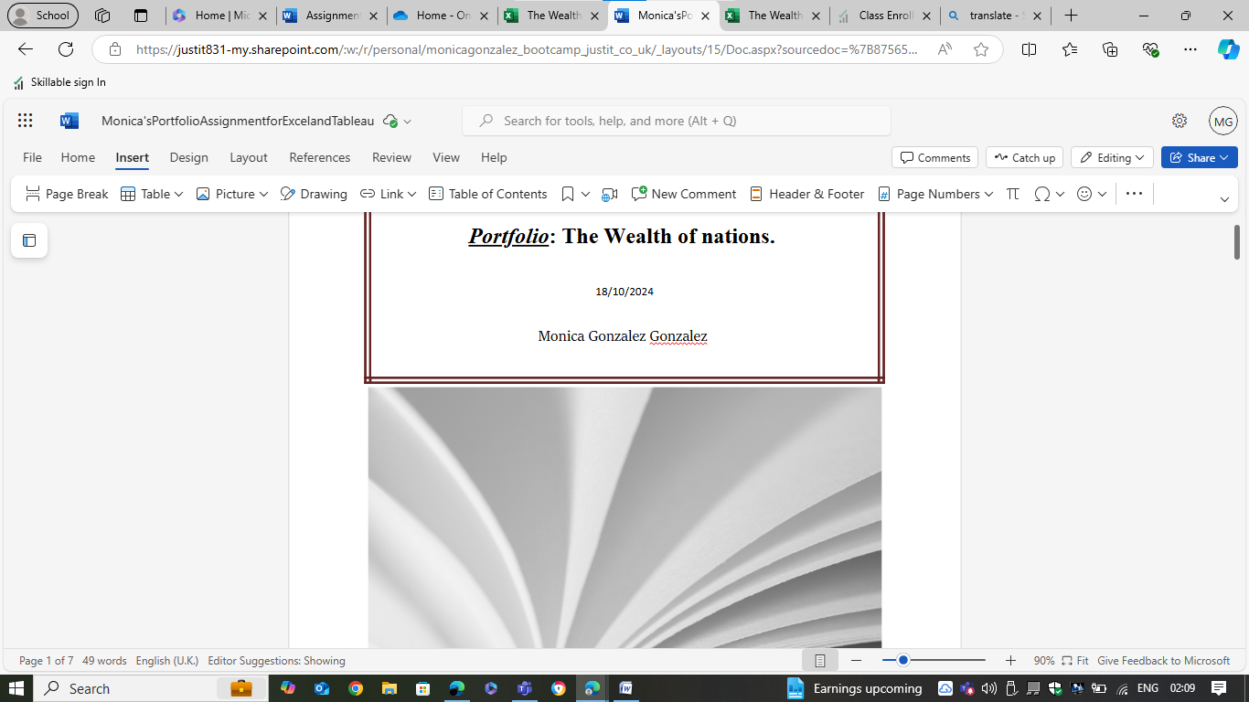

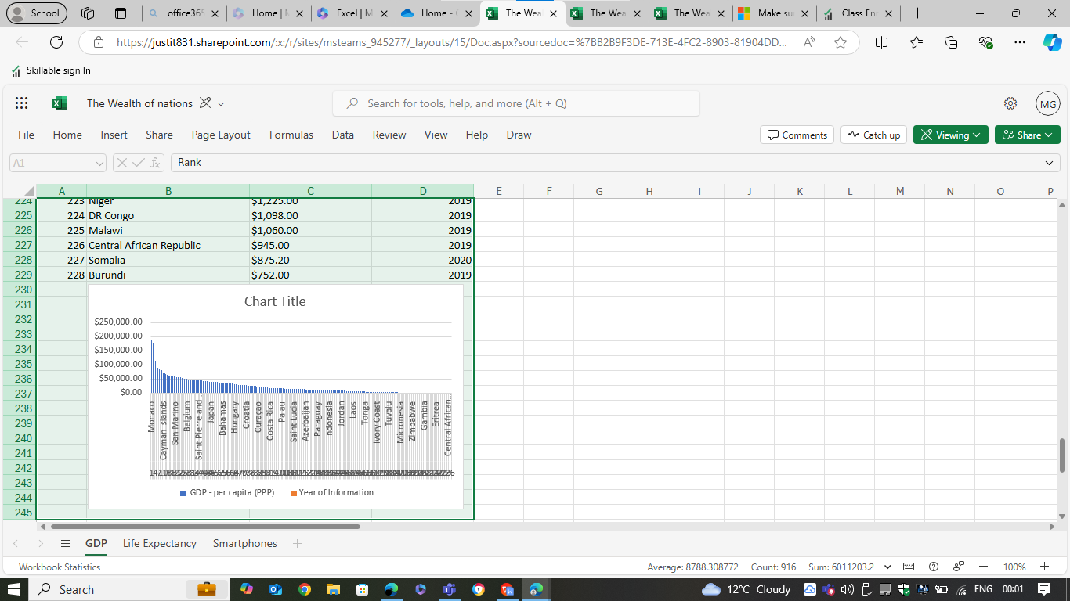Explicar...

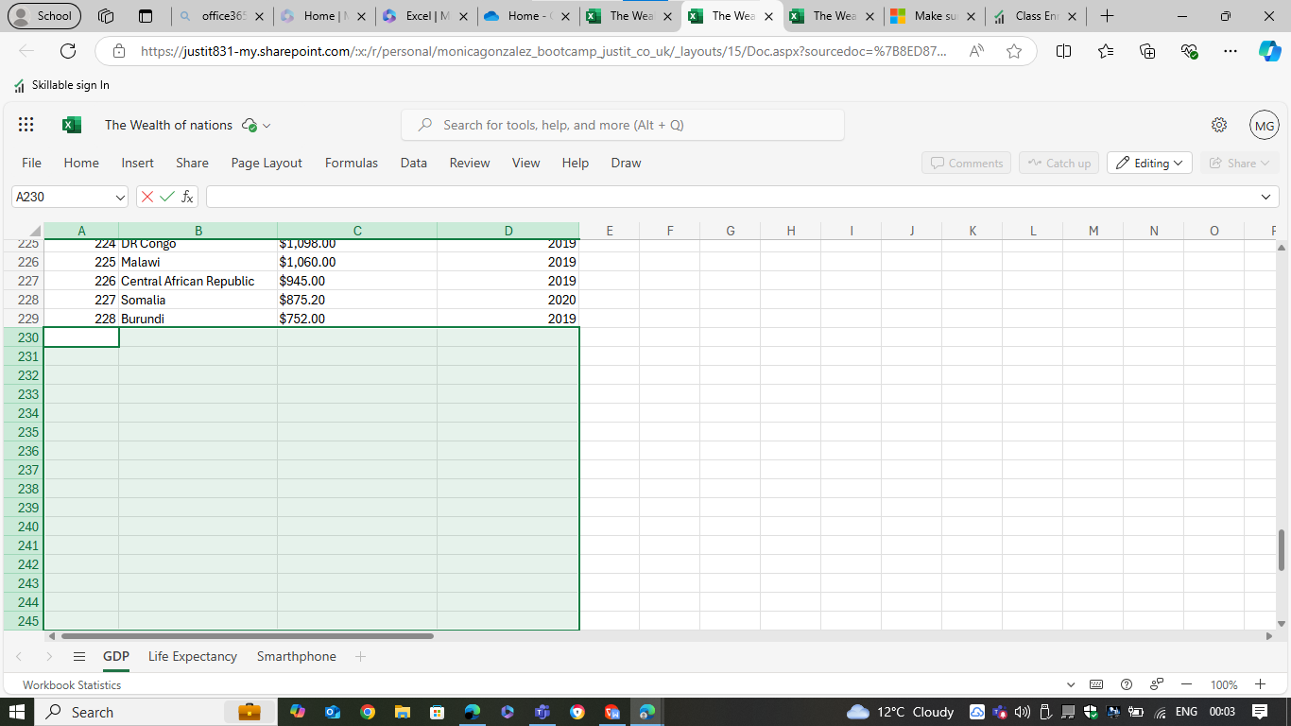

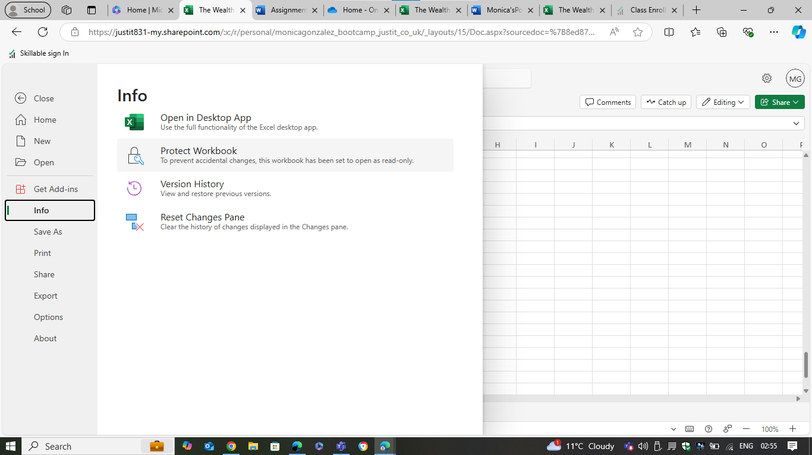

Explicar:

Select File > Info. Select the Protect Workbook box and choose Encrypt with Password. Enter a password in the Password box, and then select OK. Confirm the password in the Reenter Password box, and then select OK.

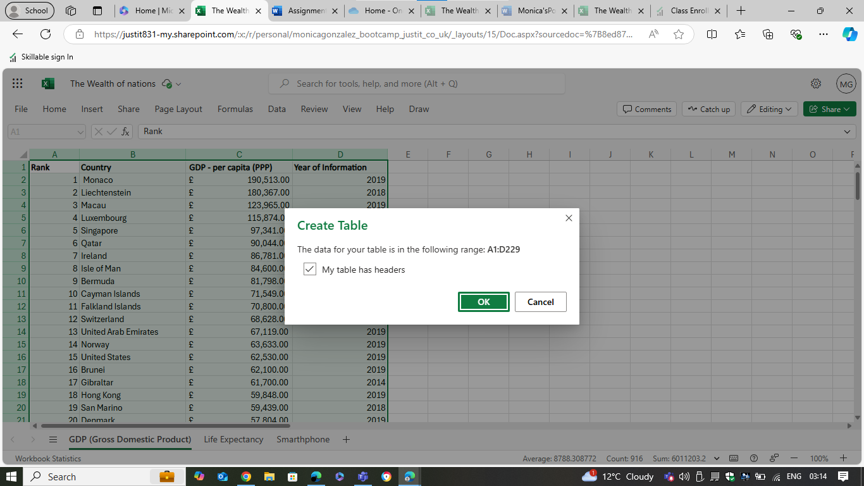

Turn the GDP sheet into a table.

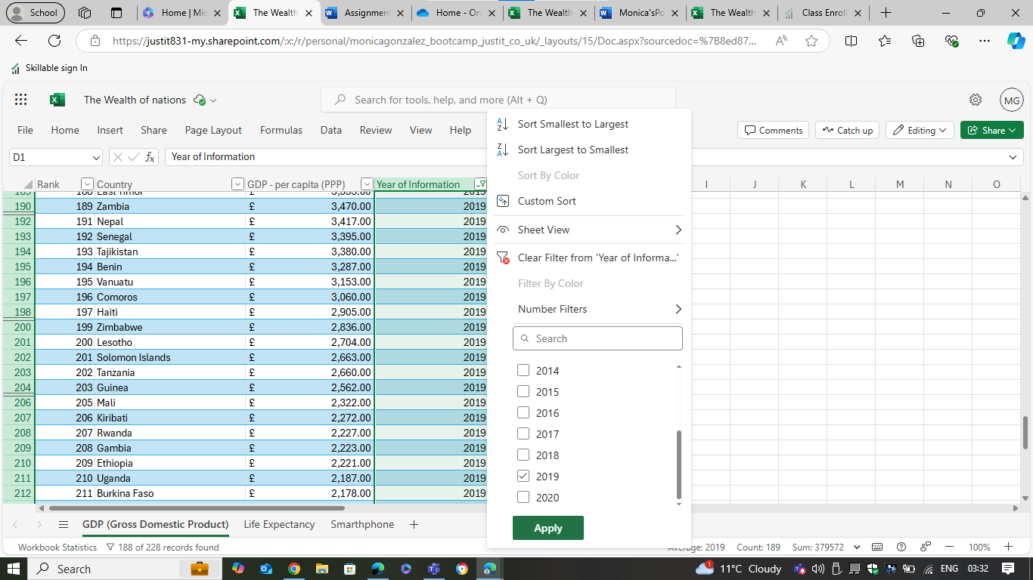

Filter the table to display only the information for 2019

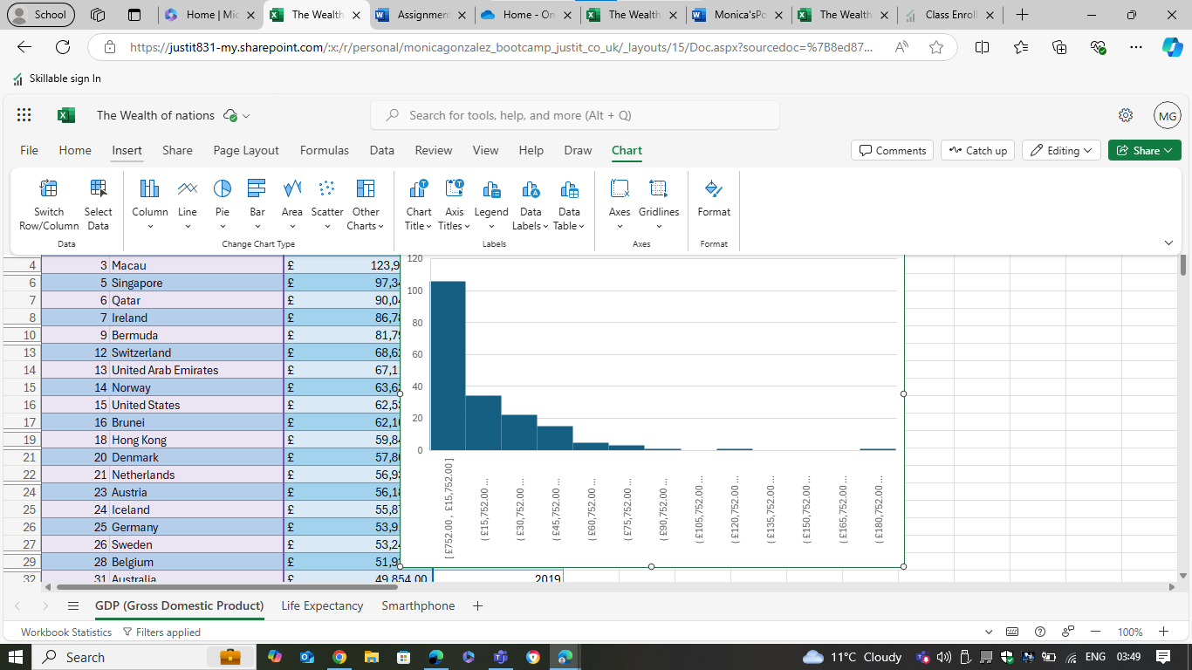

Next create a chart that will only display the following data ‘Rank, Country and GDP - per capita (PPP)

DEbido a mis limitadas opciones.............................

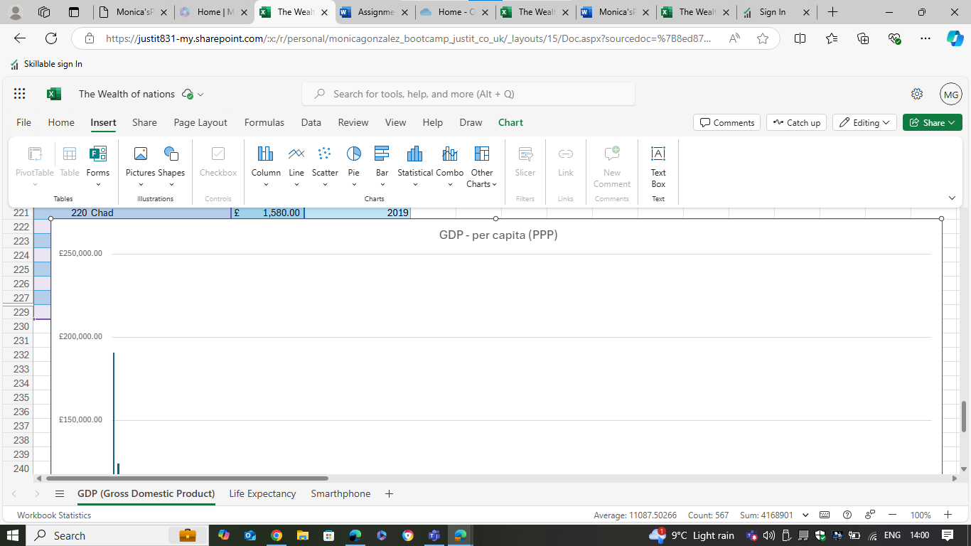

Choosing the correct chart for this case.

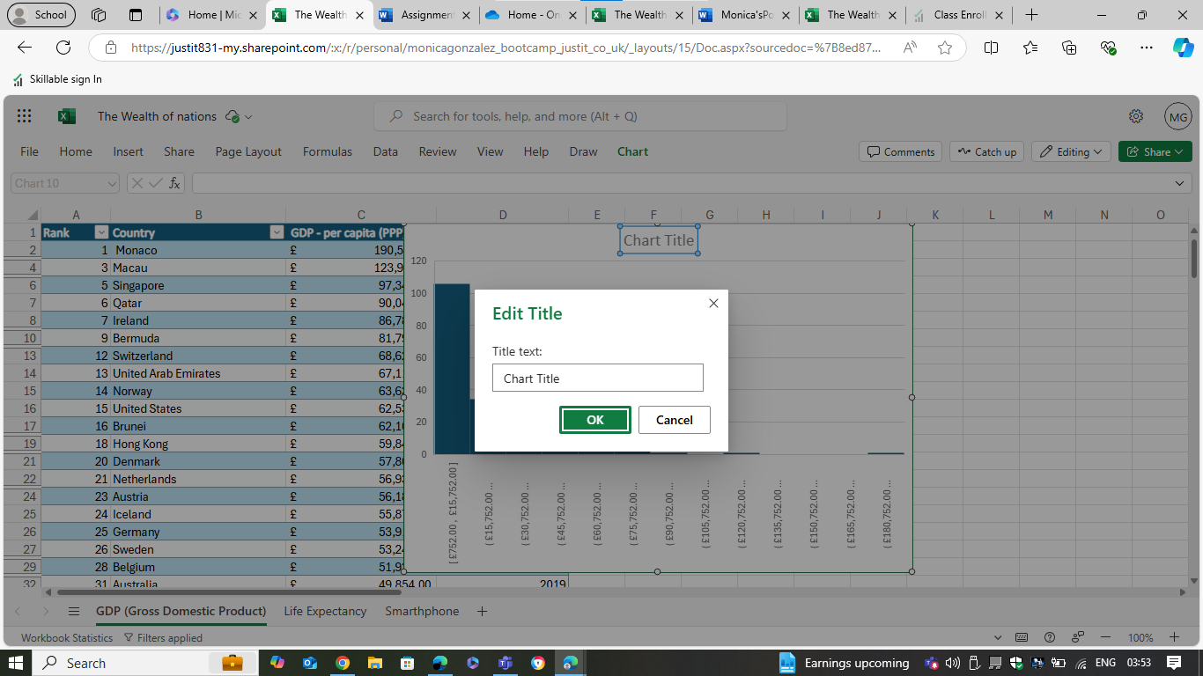

Using your creative skills edit the chart a. Add a title

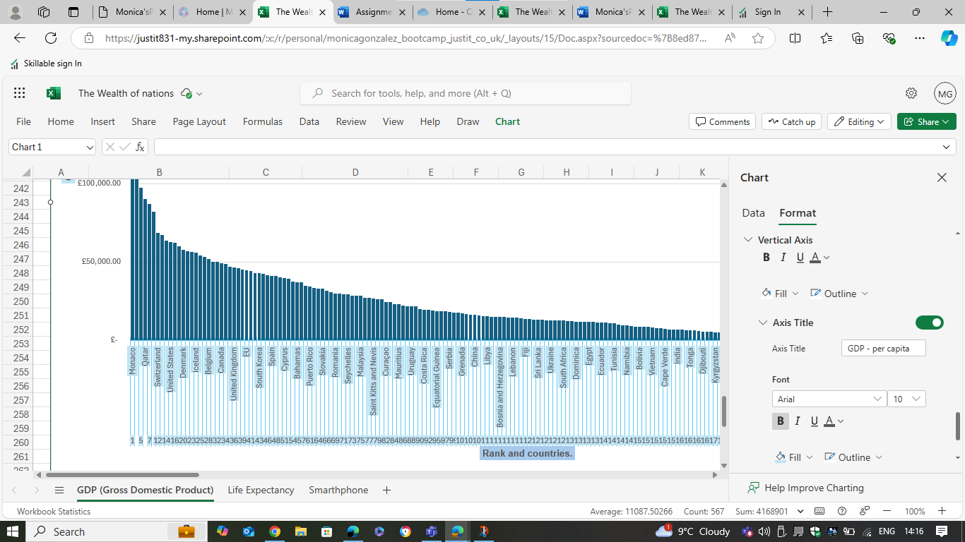

Add X and Y axis labels

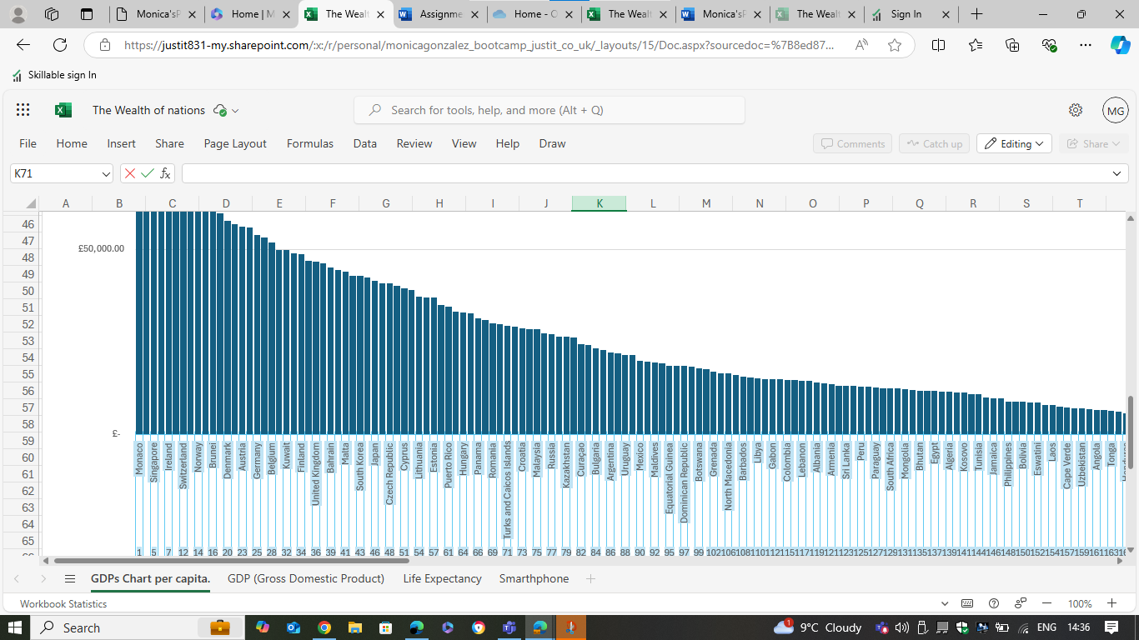

Move the chart to a new sheet tab and label with a suitable name.

Explicar que use cut y pegue en otra pagina porque en este excel no hay Chart Tools, on the Design tab, in the Location group, click Move Chart.

Luego, click New sheet, and then in the New sheet box, type a name for the worksheet.

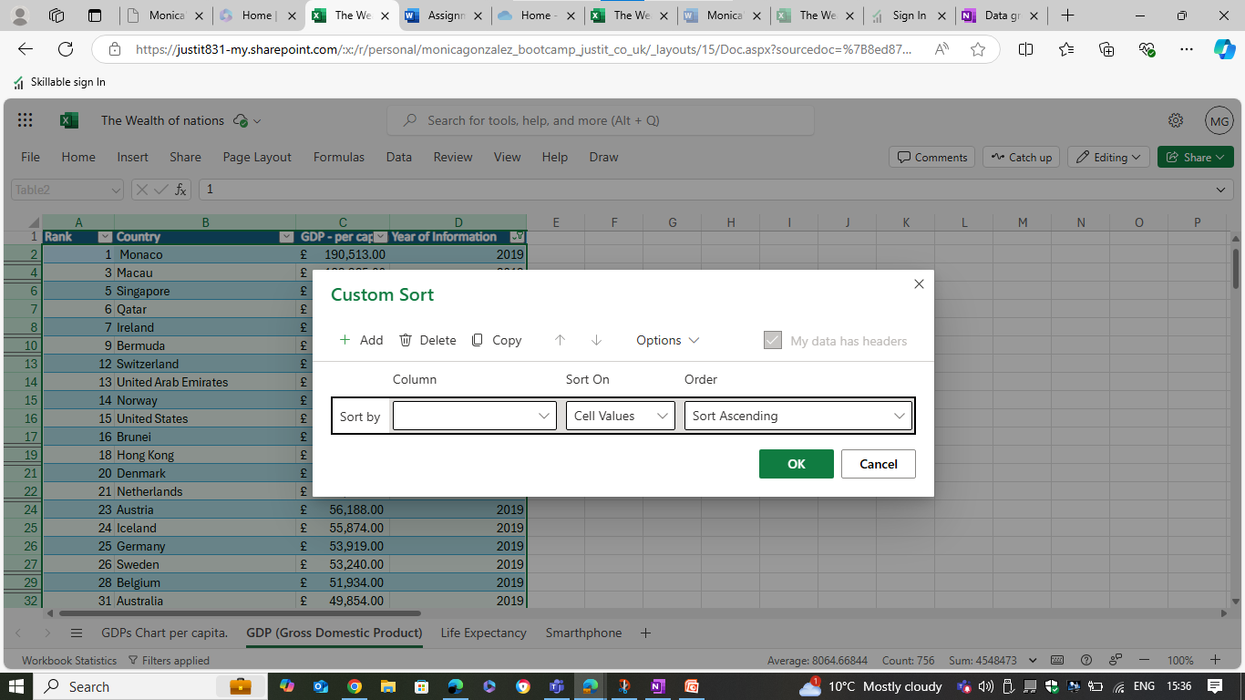

Create a sort for the top 20 highest ranking counties.

He dudado con la funcion RANK pero luego recorde por la primera actividad hecha sobre excel como homework de data sorting.

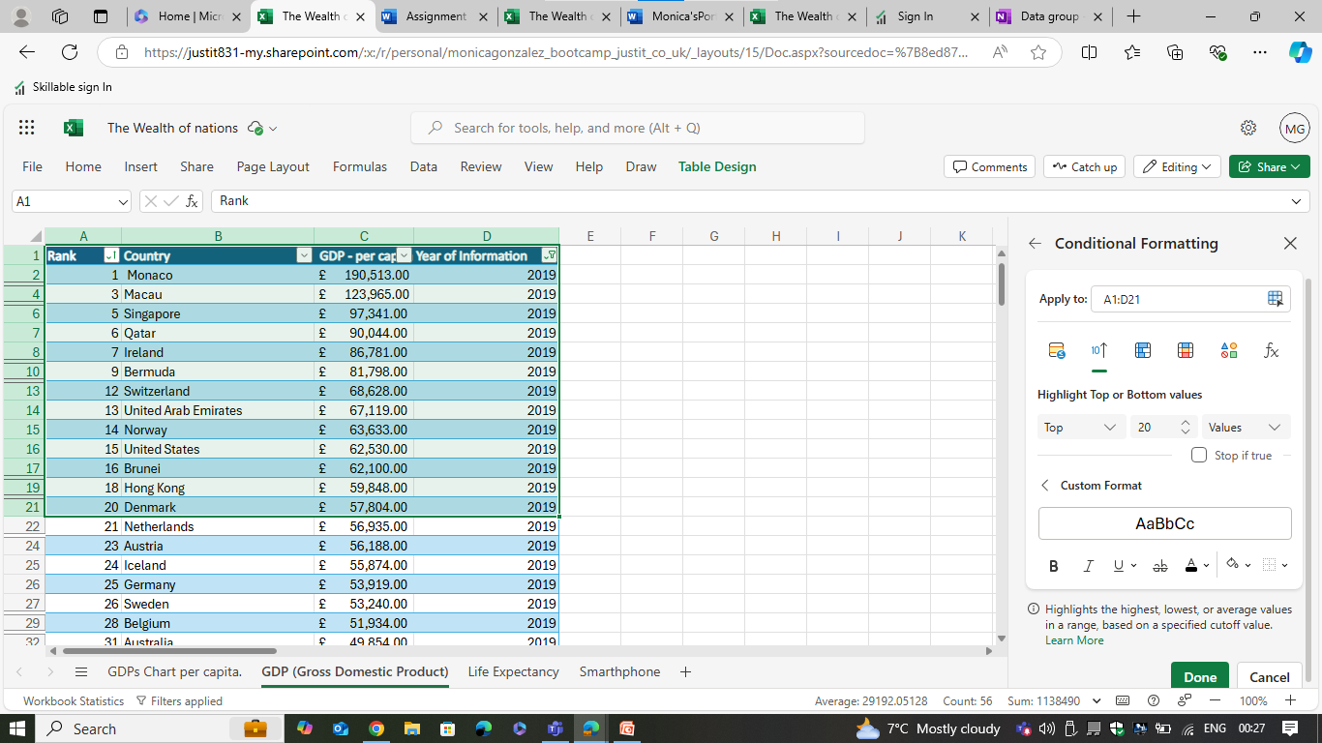

Create a sort for the top 20 highest ranking counties

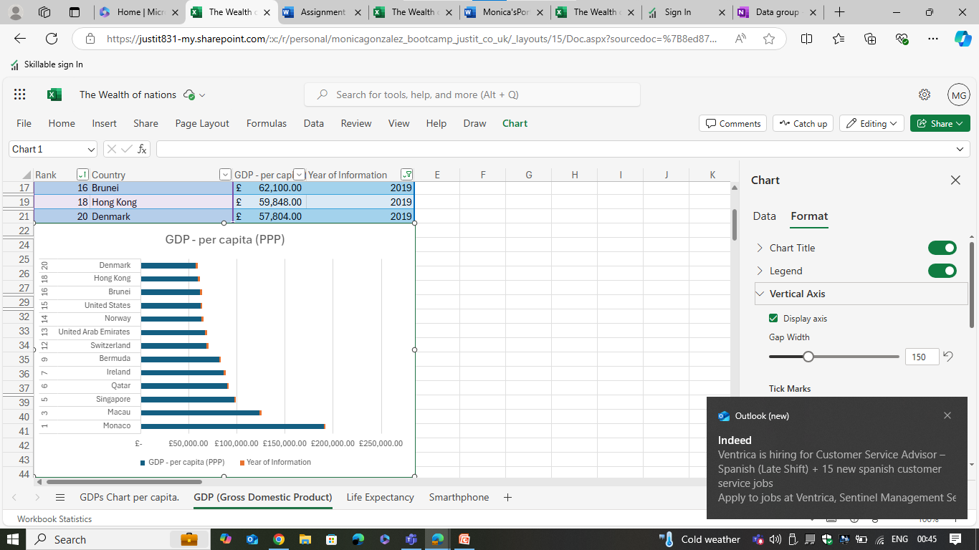

Next create a new Bar chart to display the 20 highest ranking countries from your sort and then move the chart to be underneath the table, as shown below.

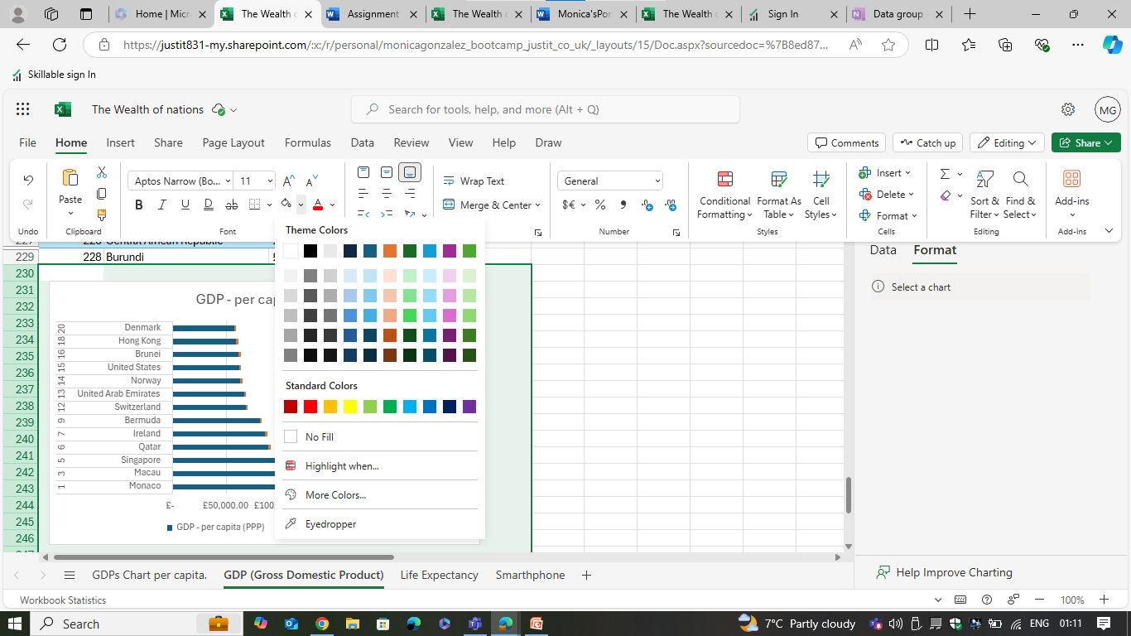

Colour the background by highlighting the area underneath the table as shown below. Find the add a fill colour icon and select a colour.

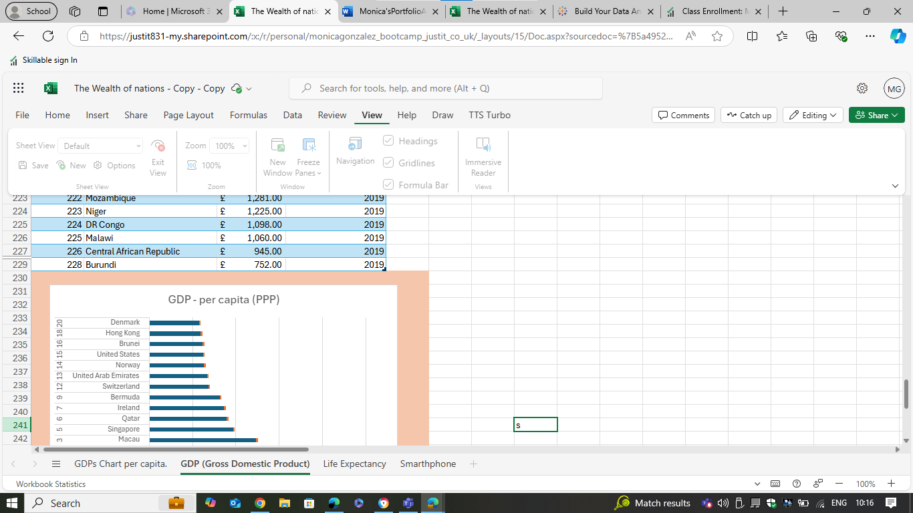

En esta version de justit no tengo la opcion de macros en view. He buscado la forma de anadirlo a esta version de excel pero no puedo. Se que macros esta en la pestana de view. He ido a file a options para activar macros pero no existe esa opcion aqui. He estado pensando en hacer todo de nuevo en otro excel pero el mio es del 2007, aunque tiene macros. Luego, he intentado hacer todo esto por medio de excel 2016 de skillable pero fue imposible mover los datos de la actividad en ese excel, lo intente tambien con otra companera del curso y no fue posible, ademas de perder horas en eso.

He tenido que abrir todo con mi excel del 2007, por lo que voy a tener dos excels, en esta version, lo guardare con un passord y el de la version, donde he hecho todo menos la macro porque no tiene ese opcion, pero si el excel del 2007, no le he puesto un passord porque no tiene ese opcion como ya he explicado anteriormente.

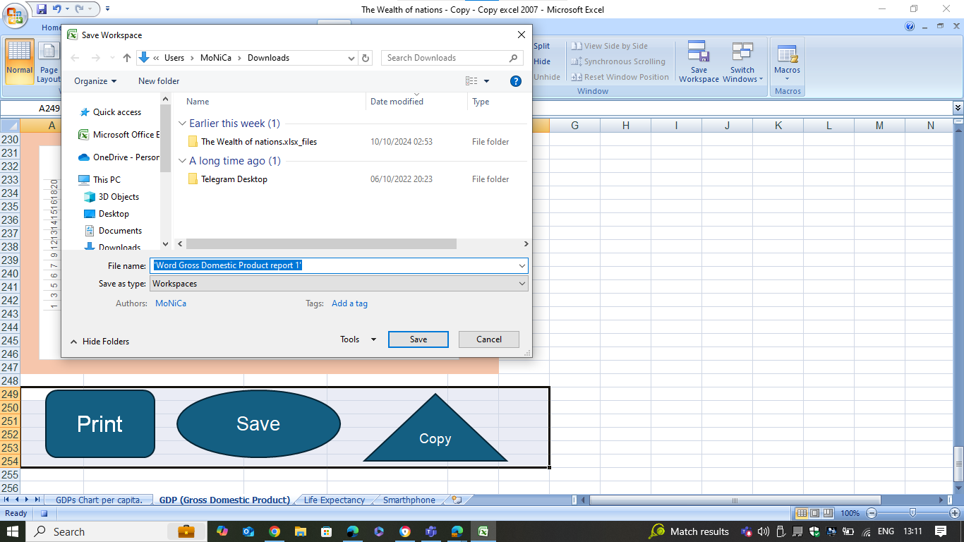

Esta captura de pantalla ya es de mi version excel 2007 y no se si he guardado correctamente en un nuevo documento de word gardando como 'Word Gross Domestic Product report 1'

Reflective:

cuenta para evaluar su proyecto, incluyendo lo que salió bien y las áreas de desarrollo y las lecciones aprendidas.

First Task

Policies and Procedures:

The [Data Protection Act 2018](http://www.legislation.gov.uk/ukpga/2018/12/contents/enacted) controls how your personal information is used by organizations, businesses or the government. (1)

The Data Protection Act 2018 is the UK’s implementation of the General Data Protection Regulation (GDPR).

Everyone responsible for using personal data has to follow strict rules called ‘data protection principles’. They must make sure the information is:

* used fairly, lawfully and transparently
* used for specified, explicit purposes
* used in a way that is adequate, relevant and limited to only what is necessary
* accurate and, where necessary, kept up to date
* kept for no longer than is necessary
* handled in a way that ensures appropriate security, including protection against unlawful or unauthorized processing, access, loss, destruction or damage

There is stronger legal protection for more sensitive information, such as:

* race
* ethnic background
* political opinions
* religious beliefs
* trade union membership
* genetics
* biometrics (where used for identification)
* health
* sex life or orientation

There are separate safeguards for personal data relating to criminal convictions and offences.

## **Your rights**

Under the Data Protection Act 2018, you have the right to find out what information the government and other organizations store about you. These include the right to:

* be informed about how your data is being used
* access personal data
* have incorrect data updated
* have data erased
* stop or restrict the processing of your data
* data portability (allowing you to get and reuse your data for different services)
* object to how your data is processed in certain circumstances

You also have rights when an organization is using your personal data for:

* automated decision-making processes (without human involvement)
* profiling, for example to predict your behavior or interests.

(1)Gov.UK.

Data protection law sets out what needs to be done to ensure that everyone’s data is used properly and fairly because if it falls into the wrong hands, people could be harmed, becoming victims of identity theft, discrimination or even physical harm.

Good data protection also makes economic sense, as it saves time and money and also shows people that their information is important, which is good for your own reputation and the brand you represent or have.

As a data analyst, it is important to know and understand the rules about data handling because this tells you when to expect to receive data, what you can do with certain data based on certain criteria and explains what should happen when transforming the data.

‘GDP (Gross Domestic Product)’.

